**Legend of Rose User Manual**

**Main Menu:**

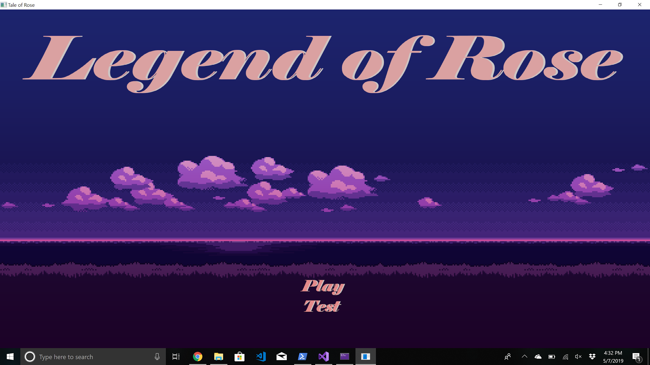

* At the main menu press ‘P’ to begin playing the game or ‘T’ to enter test mode.
* Pressing ‘T’ will exit the game and run all of the tests displayed in a separate window.
* Pressing ‘P’ will cause the game to run and wave 1 to spawn.

**Wave 1:**

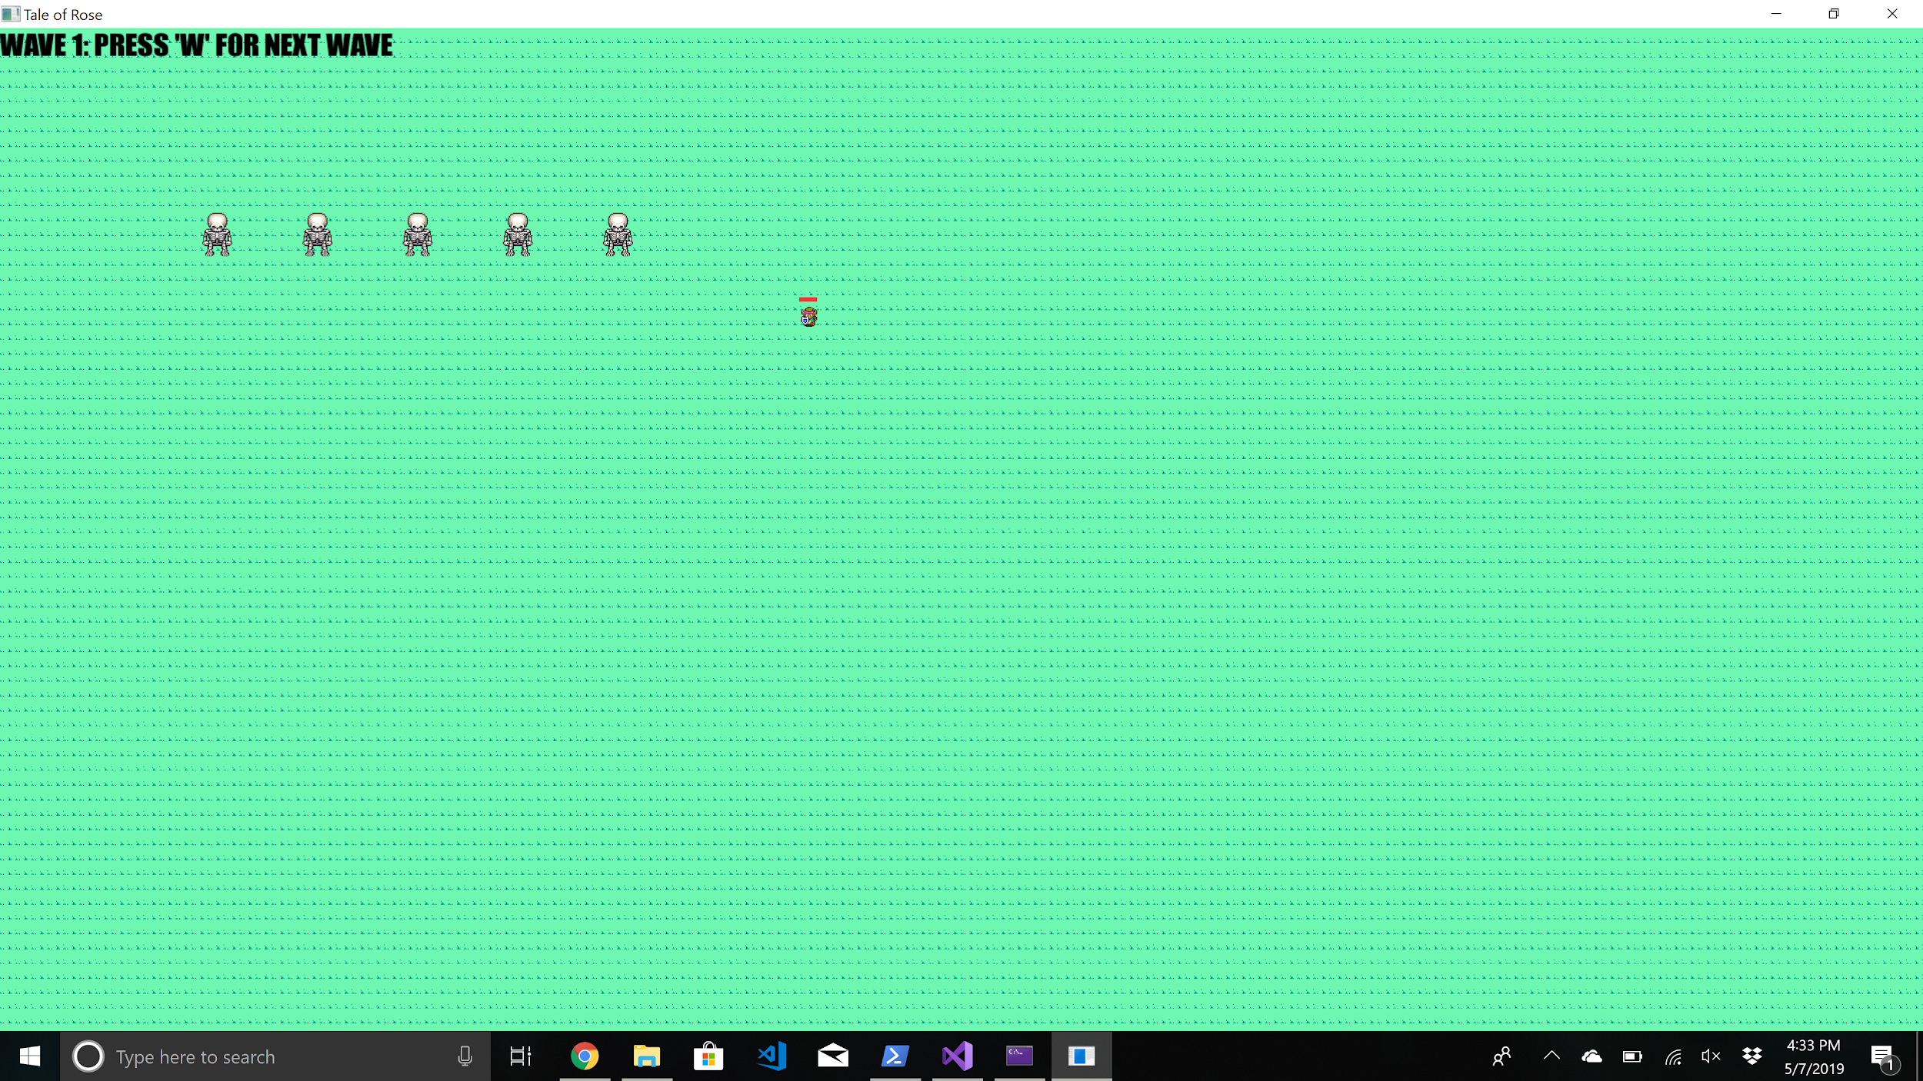

* Wave 1 begins with 5 skeletons that will immediately attack to the player.
* The objective of this game is to use Link’s attack to to kill all 5 skeletons.
* To control Link press any of the 4 arrow keys to move in the desired direction.
* When an enemy is nearby press the space key to swing Link’s sword.
* Once all of the enemies are dead, press the ‘W’ key to enter the next wave.

**Wave 2:**

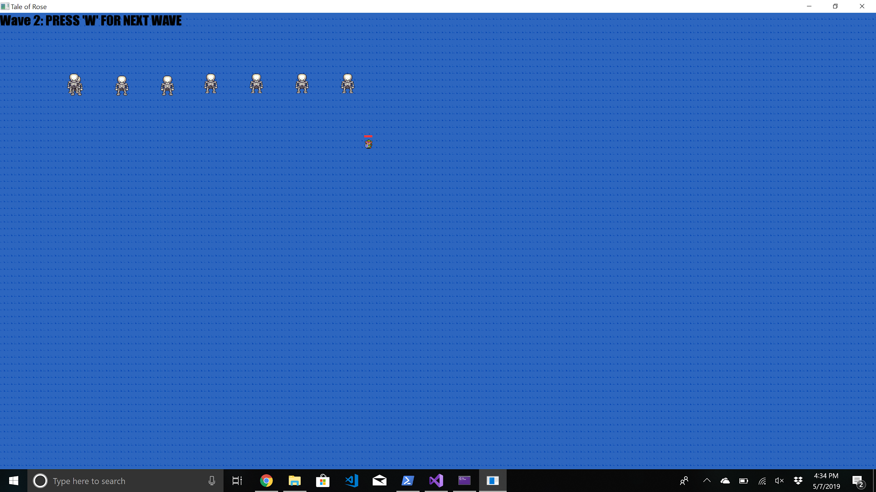

* Wave 2 contains 8 skeletons that will attack the player.
* Use the same keys to move Link and attack the skeletons.
* Once the skeletons are killed press ‘W’ again to progress to the final wave.

**Wave 3:**

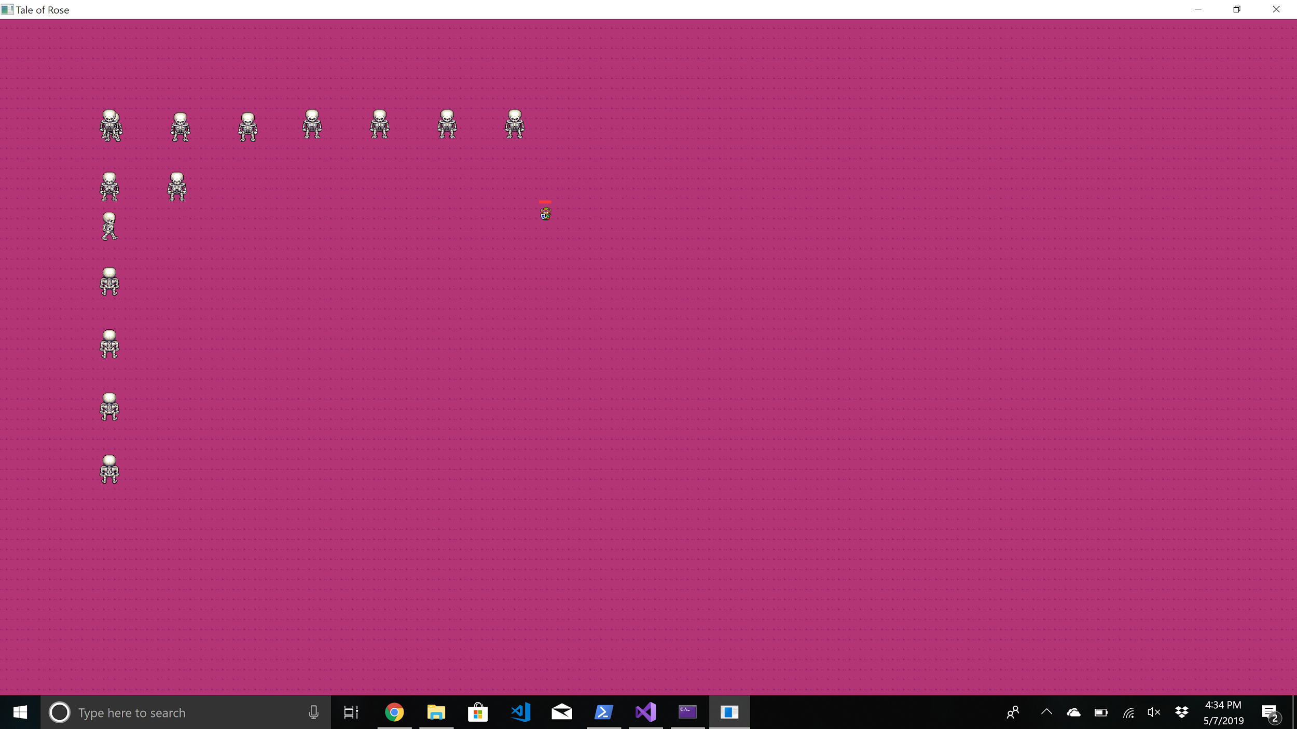

* Wave 3 will have you face 15 skeletons.
* Continue with the same control scheme to kill all 15 skeletons.
* Once all 15 skeletons are defeated, or the Main character dies the game will end.
* If all skeletons are killed a Win screen will occur, otherwise you will see the lose game screen. Examples of each screen are shown below.





* Once the game is over, restart the application to play again